
OSHA 's Form 300A (Rev. 04/2004)
Note: You can type input into this form and save it.
Because the forms in this recordkeeping package are "fillable/writable"
PDF documents, you can type into the input form fields and then save your inputs using the free Adobe PDF Reader.

Summary of Work-Related Injuries and Illnesses
All establishments covered by Part 1904 must complete this Summary page, even if no work-related injuries or illnesses occurred during the year. Remember to review the Log to verify that the entries are complete and accurate before completing this summary.
Using the Log, count the individual entries you made for each category. Then write the totals below, making sure you've added the entries from every page of theLog. If you had no cases, write •o."
Employees, former employees, and their representatives have the right to review the OSHA Fonn 300 in its entirety. They also have limited access to the OSHA Form 301 or its equivalent. See 29 CFR Part 1904.35, in OSHA's recordkeeping rule, for further details on the access provisions for these fonns.
Total number of | Total number of | Total number of cases | Total number of
deaths | cases with days away from work | with job transfer or  restriction | other recordable cases
0 | 6 | 6 | 1
(G) (H) (I) (J)
Year 20 2s

U.S. Department of Labor
Occupational Saffllly and Health Administration

Form appron:d OM B no. 1218�0176

Total number of days away from work
Industry description (e.g., Mam!facture o_fmotor /nick trailers)
Higher Education
North American Industrial Classification (NAJCS), if known (e.g., 336212)
Jsj1j 1j3j 1joj
190

Total number of days of job transfer or restriction
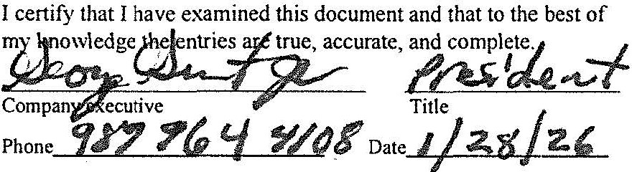
135
Sign here
Knowingly falsifying this document may resnlt in a fine.
1,576
2,043,344.00
Annual average number of employees

Total hours worked by all employees last year
Employment information (lfyo11 don't have these.figures, see the Work,-heet on the next page to estimate.)
Zip 48710
State Ml
City University Center
Establishment information

Your atab/i$hment name Saginaw Valley State University-All Facilities

Street 7400 Bay Road

(K) (L)

Total number of. .
(M)
(1) Injuries | 12 | (4) Poisonings | 0
(2) Skin disorders | 1 | (5) Hearing loss | 0
(3) Respiratory conditions | 0 | (6) All other illnesses | 0


Post this Summary page from February 1 to April 30 of the year following the year covered by the form.
Public reporting burden for this collection ofinfonnation is estimated to 3\'crage 58 minutes per response, including time to review the instructions, search and gather the data needed, and complete and review the collection of information. Persons rue not required to respond to the collection of information unless it displays a currently valid 0MB control number. If you have any comments about these estimates or any other aspects of this data collection,. contact: US Department of Labor, OSHA Office of Statistical Analysis, Room N-3644, 200 Constitution A\·cnuc, NW, Washington, DC 20210, Do not send the completed fonns to this office.

